5 Complex Query & Screenshot Results
Referee strictness
SELECT
r.refereename, AVG(ght.penalities) AS avg_penalties_per_game,
CASE
WHEN AVG(ght.penalities) >= 10 THEN 'Strict'
WHEN AVG(ght.penalities) >= 5 THEN 'Average'
ELSE 'Lenient'
END AS strictness_category
FROM referee AS r
JOIN game_has_referee AS ghr
ON ghr.idReferee = r.idreferee
JOIN game_has_teams AS ght
ON ght.Game_idGame = ghr.idGame
GROUP BY
r.refereename
ORDER BY
avg_penalties_per_game DESC;
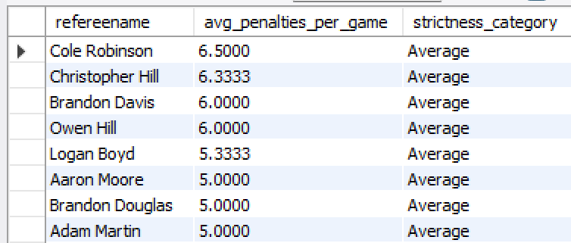

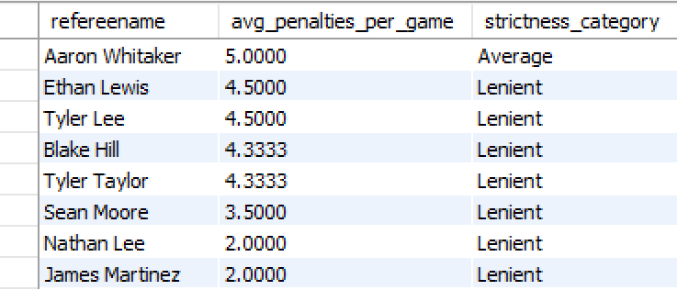

Managerial Reasoning:
This query averages the overall penalties that refs make to gauge their level of strictness. Knowing how strict referees are can help coaching staff prepare players for the flow of the game and plan game strategy according to how strict referees are.

## Query 2

# Query

Average point differential by team- error game team stats

```sql

SELECT
t.Teamname,
AVG(g.totalhome - g.totalaway) AS avg_point_diff
FROM team AS t
JOIN game_has_teams AS gts
ON t.idteam = gts.Team_idTeam
JOIN games AS g
ON g.idgames = gts.Game_idGame
GROUP BY t.Teamname
ORDER BY avg_point_diff DESC;

```
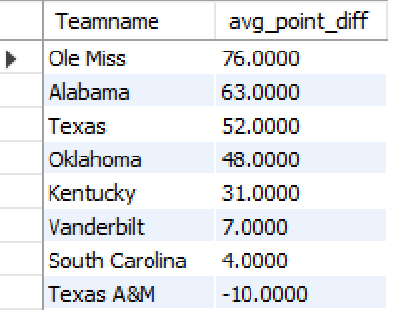

# Managerial Reasoning

Point differential is a better measure of team strength than wins alone.
Teams with high differentials are dominating games, not winning by luck.
Conference leaders and coaching staff can use this to judge true performance and predict championship contenders.

---

## Query 3- we do not have a access to view so i can’t run it

# Query

Average home attendance using a view

```sql
-- Step 1: Create the view
CREATE OR REPLACE VIEW home_attendance AS
SELECT
t.teamname,
g.attendance
FROM games AS g
JOIN team AS t
ON g.Stadium_idStadium = t.homestadiumID;

-- Step 2: Query the view
SELECT
teamname,
AVG(attendance) AS avg_home_attendance
FROM home_attendance
GROUP BY teamname
ORDER BY avg_home_attendance DESC;

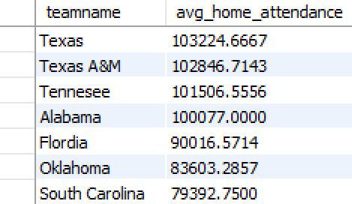
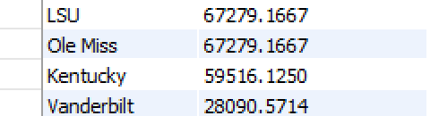
```

# Managerial Reasoning

Attendance shows the strength of a teams brand and fan engagement.
High attendance supports revenue, stadium investments, and marketing plans.
Low attendance can show weak fan support or gaps in game day experience.

---

## Query 4

# Query

Weather impact on scoring

```sql
WITH weather_points AS (
SELECT
weather,
(totalhome + totalaway) AS total_points
FROM games
)
SELECT
weather,
AVG(total_points) AS avg_points_scored
FROM weather_points
GROUP BY weather
ORDER BY avg_points_scored DESC;

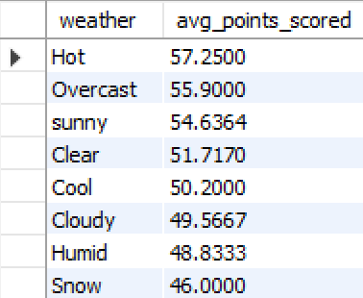```

# Managerial Reasoning

Weather affects scoring and team performance.
This helps coaches prepare for bowl games, late season travel, and games in unfamiliar climates.
Teams can decide if they should train more in rain, heat, or cold depending on the results.

---

## Query 5

# Query

Turnover impact on win percentage

```sql

SELECT
t.Teamname,
AVG(ght.turnovers) AS avg_turnovers,
SUM(
CASE
WHEN ght.Team_idTeam = t.idteam
AND (
(ght.Team_idTeam = t.idteam AND g.totalhome > g.totalaway)
) THEN 1
ELSE 0
END
) AS wins,
COUNT(*) AS total_games,
(
SUM(
CASE
WHEN ght.Team_idTeam = t.idteam
AND (
(ght.Team_idTeam = t.idteam AND g.totalhome > g.totalaway)
) THEN 1
ELSE 0
END
) / COUNT(*)
) AS win_percentage
FROM team AS t
JOIN game_has_teams AS ght
ON t.idteam = ght.Team_idTeam
JOIN games AS g
ON g.idgames = ght.Game_idGame
GROUP BY t.Teamname
ORDER BY win_percentage DESC;

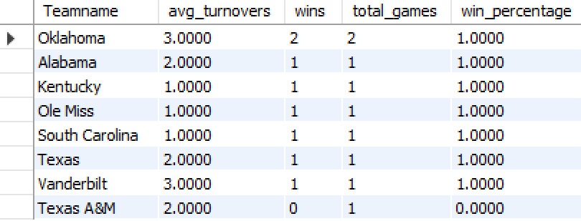
```

# Managerial Reasoning

Turnovers have a big effect on game outcome.
Teams that protect the ball win more.
Coaches can use this to focus training on ball security, quarterback decision making, and forcing defensive turnovers.
This gives a clear picture of how much turnovers affect winning in the SEC.

